Nginx

# Nginx

## 安装PCRE， OPENSSL

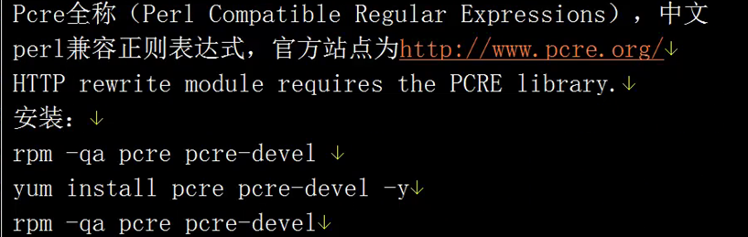

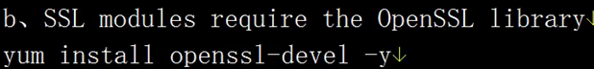

## 安装Nginx

wget -q <http://nginx.org/download/nginx-1.6.3.tar.gz>

[root@centos6-server1 opt]# tar zxf nginx-1.6.3.tar.gz

[root@centos6-server1 nginx-1.6.3]# useradd nginx –s /sbin/nologin -M

[root@centos6-server1 nginx-1.6.3]# ./configure --prefix=/usr/local/nginx-1.6.3/ --user=nginx --group=nginx --with-http_ssl_module --with-http_stub_status_module

[root@centos6-server1 nginx-1.6.3]# make && make install

[root@centos6-server1 ~]# nginx/sbin/nginx -V

nginx version: nginx/1.6.3

built by gcc 4.4.7 20120313 (Red Hat 4.4.7-16) (GCC)

TLS SNI support enabled

configure arguments: --prefix=/usr/local/nginx-1.6.3/ --user=nginx --group=nginx --with-http_ssl_module --with-http_stub_status_module

## 基于域名的虚拟主机：

配置多个基于域名的虚拟主机的时候， 如果用IP访问则访问第一个虚拟主机。

一个server 标签就是就是一个虚拟主机。

[leo@centos6-server1 conf]$ cat nginx.conf

worker_processes 1;

events {

worker_connections 1024;

}

http {

include mime.types;

default_type application/octet-stream;

sendfile on;

keepalive_timeout 65;

server {

listen 80;

server_name [www.vip.com](http://www.vip.com) vip.com;

location / {

root html/www;

index index.html index.htm;

}

error_page 500 502 503 504 /50x.html;

location = /50x.html {

root html;

}

}

server {

listen 80;

server_name www.vipshop.com;

location / {

root html/vipshop;

index index.html index.htm;

}

error_page 500 502 503 504 /50x.html;

location = /50x.html {

root html;

}

}

}

## 4.虚拟主机别名配置

可以用于对集群中的主机起别名， 以方便监控区别之用。

## Nginx 状态信息

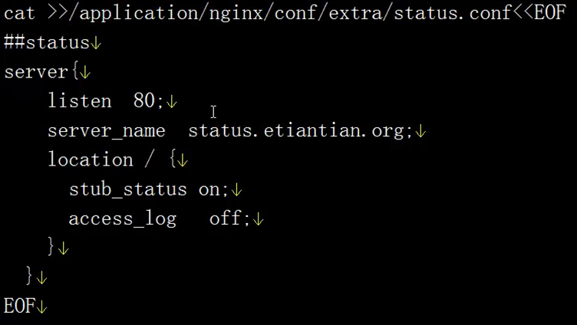

[root@centos6-server1 conf]# cat extra/status.conf

##status

server {

listen 80;

server_name status.vip.com;

location / {

stub_status on;

access_log off;

}

}

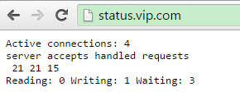

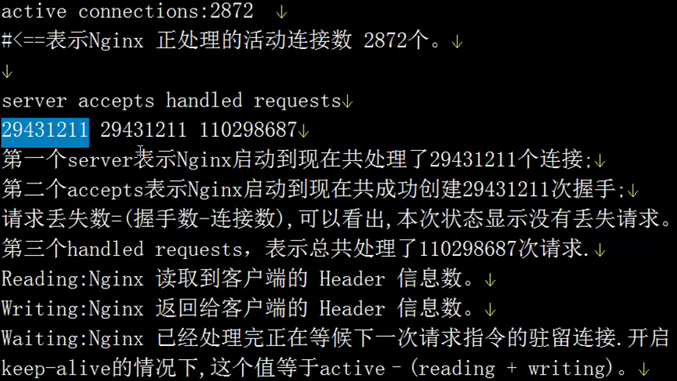

## 访问日志

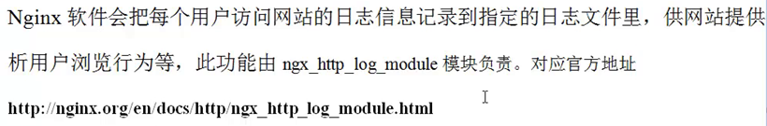

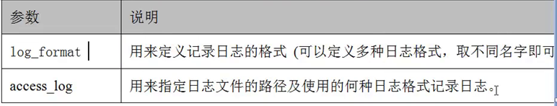

log_format main '$remote_addr - $remote_user [$time_local] "$request" '

'$status $body_bytes_sent "$http_referer" '

'"$http_user_agent" "$http_x_forwarded_for"';

access_log logs/access.log main;



每个虚拟主机配置一个日志文件 。

## 日志轮询切割

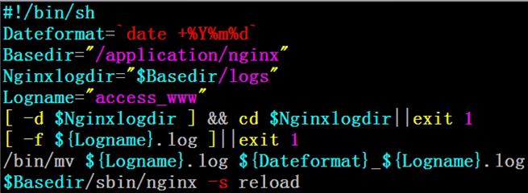



# Mysql

## 二进制包安装mysql

安装文件：

<http://ftp.ntu.edu.tw/pub/MySQL/Downloads/MySQL-5.5/mysql-5.5.32-linux2.6-x86_64.tar.gz>

[root@centos6-server2 ~]# useradd -s /sbin/nologin -M mysql

[root@centos6-server2 opt]# tar xf mysql-5.5.32-linux2.6-x86_64.tar.gz

[root@centos6-server2 opt]# mv mysql-5.5.32-linux2.6-x86_64 /usr/local/mysql-5.5.32

[root@centos6-server2 ~]# ln -s /usr/local/mysql-5.5.32/ mysql

[root@centos6-server2 mysql-5.5.32]# /usr/local/mysql-5.5.32/scripts/mysql_install_db --basedir=/usr/local/mysql-5.5.32/ --datadir=/usr/local/mysql-5.5.32/data/ --user=mysql

修改数据库字符集为utf8:

[root@centos6-server2 data]# vi /etc/my.cnf

[client]

#password = your_password

port = 3306

socket = /tmp/mysql.sock

# Here follows entries for some specific programs

default-character-set=utf8

[mysqld]

character-set-server=utf8

## 2.备份数据库

[root@centos6-server2 scripts]# mysqldump -uroot -proot -B -A --events -x|gzip>/opt/back_$(date +%F).sql.gz

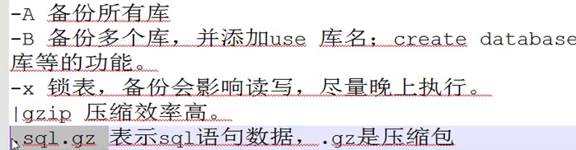单库：



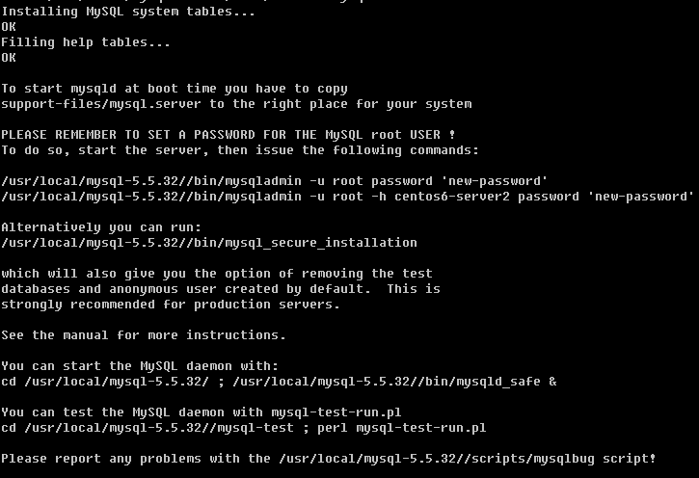

[root@centos6-server2 local]# chown -R mysql.mysql /usr/local/mysql-5.5.32

[root@centos6-server2 mysql-5.5.32]# cp support-files/my-medium.cnf /etc/my.cnf

[root@centos6-server2 local]# ln -s /usr/local/mysql-5.5.32/ mysql

注意：如果安装路径在别的地方，需要修改启动脚本中的路径。

MYSQL_HOME/bin/mysqld_safe

例如：



启动：

[root@centos6-server2 bin]# /usr/local/mysql/bin/mysqld_safe &

把mysql/bin 加到环境变量path 中。

登录测试：

[root@centos6-server2 bin]# mysql

配置mysql 服务启动脚本：

[root@centos6-server2 bin]# cp /usr/local/mysql/support-files/mysql.server /etc/init.d/mysqld

[root@centos6-server2 bin]# chmod +x /etc/init.d/mysqld

[root@centos6-server2 bin]# /etc/init.d/mysqld start

Starting MySQL.. SUCCESS!

[root@centos6-server2 bin]# chkconfig mysqld on

[root@centos6-server2 bin]# chkconfig --list mysqld

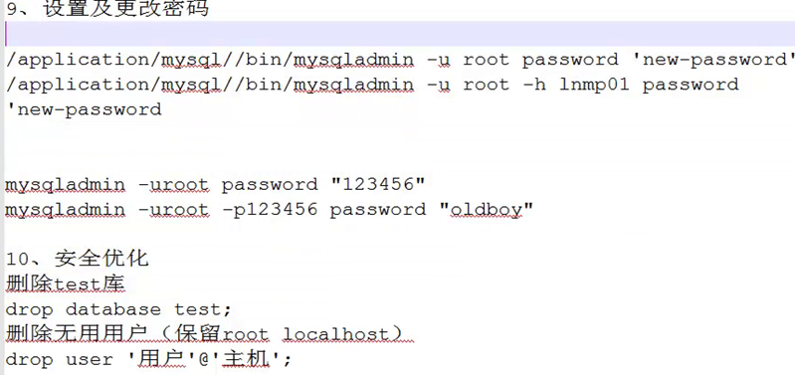

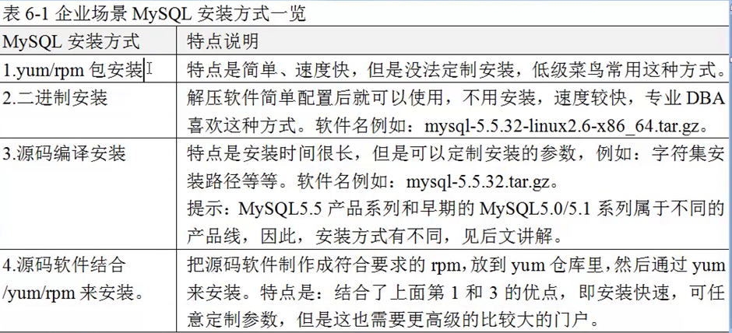

# FASTCGI

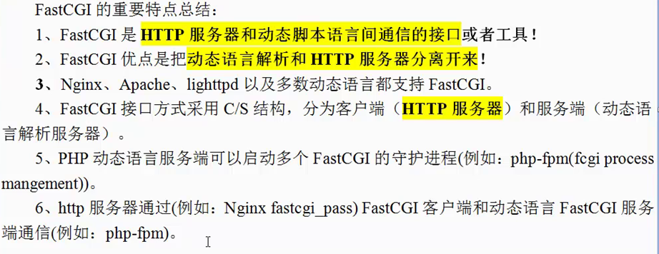

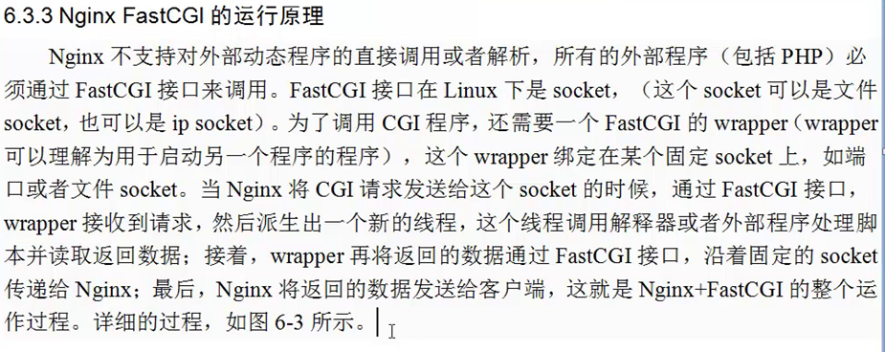

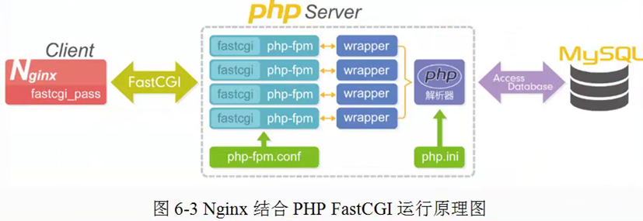

## php 依赖库安装

### 检查依赖包 ：

[root@centos6-server2 ~]# rpm -qa zlib_devel libxml2-devel libjpeg-turbo-devel libiconv-devel

[root@centos6-server2 ~]# rpm -qa freetype-devel libpng-devel gd-devel libcurl-devel libxslt-devel

### 安装依赖包：

[root@centos6-server2 ~]# yum install zlib_devel libxml2-devel libjpeg-turbo-devel libiconv-devel -y

[root@centos6-server2 ~]# yum install freetype-devel libpng-devel gd-devel libcurl-devel libxslt-devel –y

### libiconv 默认yum源中没有

[root@centos6-server2 opt]# wget <http://ftp.gnu.org/pub/gnu/libiconv/libiconv-1.14.tar.gz>

[root@centos6-server2 opt]# tar zxf libiconv-1.14.tar.gz

[root@centos6-server2 opt]# cd libiconv-1.14

[root@centos6-server2 libiconv-1.14]# ./configure --prefix=/usr/local/libiconv

[root@centos6-server2 libiconv-1.14]# make && make install

### 安装libmcrypt 库

[root@centos6-server2 libiconv-1.14]# wget http://sourceforge.net/projects/mcrypt/files/Libmcrypt/2.5.8/libmcrypt-2.5.8.tar.gz

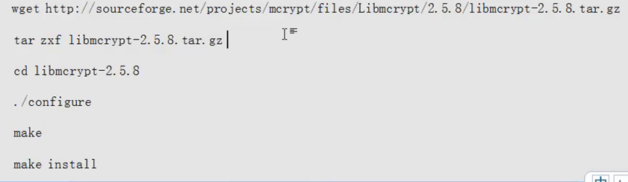

可以用下面的源安装

wget -O /etc/yum.repos.d/epel.repo <http://mirrors.aliyun.com/repo/epel-6.repo>

[root@centos6-server2 yum.repos.d]# yum install libmcrypt-devel -7

### 安装mhash

[root@centos6-server2 yum.repos.d]# yum install mhash mhash-devel –y

### 安装mcrypt

[root@centos6-server2 yum.repos.d]# yum install mcrypt -y

## PHP安装

[root@centos6-server2 opt]# tar zxf php-5.3.2.tar.gz

[root@centos6-server2 opt]# cd php-5.3.29/

[root@centos6-server2 php-5.3.29]# ./configure --prefix=/usr/local/php5.3.29 --with-mysql=/usr/local/mysql --with-iconv-dir=/usr/local/libiconv --with-freetype-dir --with-jpeg-dir --with-png-dir --with-zlib --with-libxml-dir=/usr --enable-xml --disable-rpath --enable-safe-mode --enable-bcmath --enable-shmop --enable-sysvsem --enable-inline-optimization --with-curl --with-curlwrappers --enable-mbregex --enable-fpm --enable-mbstring --with-mcrypt --with-gd --enable-gd-native-ttf --with-openssl --with-mhash --enable-pcntl --enable-sockets --with-xmlrpc --enable-zip --enable-soap --enable-short-tags --enable-zend-multibyte --enable-static --with-xsl --with-fpm-user=nginx --with-fpm-group=nginx --enable-ftp

[root@centos6-server2 php-5.3.29]# echo $?

0

[root@centos6-server2 php-5.3.29]# ln -s /usr/local/mysql/lib/libmysqlclient.so.18 /usr/lib64/

[root@centos6-server2 php-5.3.29]# touch ext/phar/phar.phar

[root@centos6-server2 php-5.3.29]# make

[root@centos6-server2 php-5.3.29]# make install

如果编前没有创建那个软链接， 编译过程中会出现的错误：

/opt/php-5.3.29/sapi/cli/php: error while loading shared libraries: libmysqlclient.so.18: cannot open shared object file: No such file or directory

make: *** [ext/phar/phar.php] Error 127

[root@centos6-server2 php-5.3.29]# ln -s /usr/local/mysql/lib/libmysqlclient.so.18 /usr/lib64/

[root@centos6-server2 php-5.3.29]# touch ext/phar/phar.phar

### php 5.5

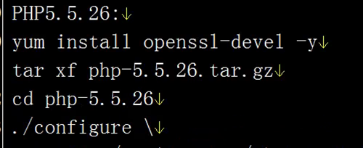

[root@centos6-server2 php-5.3.29]# ./configure --prefix=/usr/local/php5.5.26 --with-mysql=mysqlnd --with-iconv-dir=/usr/local/libiconv --with-freetype-dir --with-jpeg-dir --with-png-dir --with-zlib --with-libxml-dir=/usr --enable-xml --disable-rpath --enable-bcmath --enable-shmop --enable-sysvsem --enable-inline-optimization --with-curl --enable-mbregex --enable-fpm --enable-mbstring --with-mcrypt --with-gd --enable-gd-native-ttf --with-openssl --with-mhash --enable-pcntl --enable-sockets --with-xmlrpc --enable-zip --enable-soap --enable-short-tags --enable-static --with-xsl --with-fpm-user=nginx --with-fpm-group=nginx --enable-ftp –enable-opcache

### php.ini

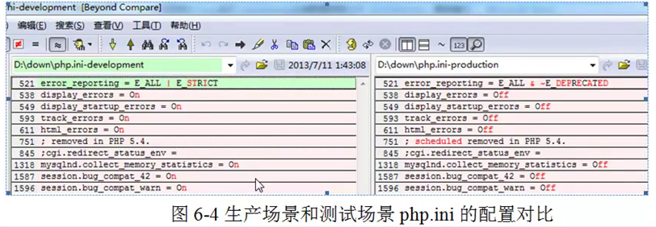

[root@centos6-server2 php-5.3.29]# cp php.ini-production /usr/local/php/lib/php.ini

[root@centos6-server2 php-5.3.29]# cd /usr/local/php/etc/

[root@centos6-server2 etc]# cp php-fpm.conf.default php-fpm.conf

启动PHP—FPM

/usr/local/php/sbin/php-fpm

如果没有什么显示，表示正常启动了

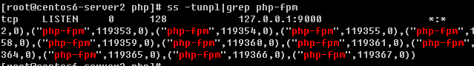

# NP整合

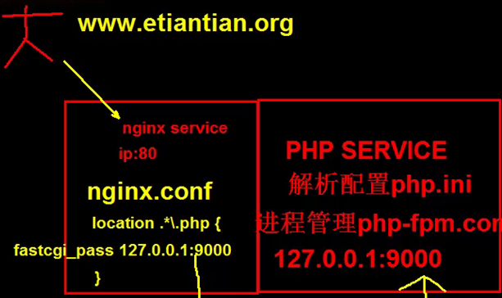

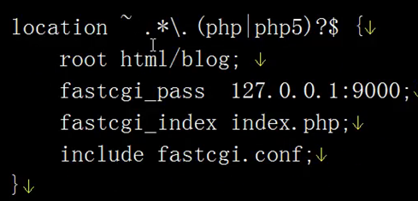

[root@centos6-server2 nginx]# vi conf/extra/blog.conf

server {

listen 80;

server_name www.blog.com blog.com;

location / {

root html/www;

index index.html index.htm;

}

location ~ .*\.(php|php5)?$ {

root html/blog;

fastcgi_pass 127.0.0.1:9000;

fastcgi_index index.php;

include fastcgi.conf;

}

access_log logs/access_blog.log main;

}

# 安装wordpress

## 创建数据库和用户

mysql> create database wordpress;

Query OK, 1 row affected (0.00 sec)

mysql> grant all on wordpress.* to wordpress@'localhost' identified by '123456';

Query OK, 0 rows affected (0.00 sec)

mysql> flush privileges;

1. 下载程序

wget <https://cn.wordpress.org/wordpress-4.4.2-zh_CN.tar.gz>

[root@centos6-server2 blog]# find . -type f|xargs chmod 644

[root@centos6-server2 blog]# find . -type d|xargs chmod 755

[root@centos6-server2 blog]# find . -type d -name "*.php"| xargs chown -R root.root

[root@centos6-server2 blog]# find . -type d|xargs chown -R root.root

[root@centos6-server2 blog]# mkdir wp-content/uploads

[root@centos6-server2 blog]# chown -R nginx.nginx wp-content/uploads/

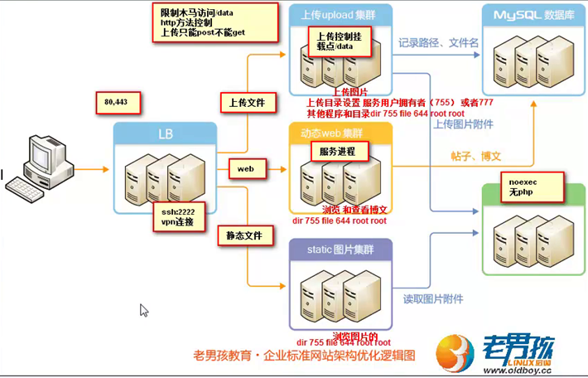

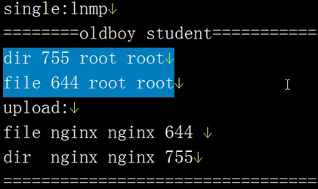

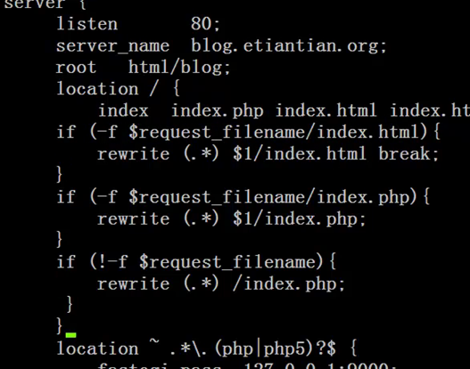

[root@centos6-server2 nginx]# cat conf/extra/blog.conf

server {

listen 80;

server_name www.blog.com blog.com;

location / {

root html/blog;

index index.php index.html index.htm;

if (-f $request_filename/index.html) {

rewrite (.*) $1/index.html break;

}

if (-f $request_filename/index.php) {

rewrite (.*) $1/index.php;

}

if (!-f $request_filename) {

rewrite (.*) /index.php;

}

}

location ~ .*\.(php|php5)?$ {

root html/blog;

fastcgi_pass 127.0.0.1:9000;

fastcgi_index index.php;

include fastcgi.conf;

}

access_log logs/access_blog.log main;

}

# 负载均衡服务器

## 6.1绑定虚拟IP

[root@centos6-lb-server ~]# ip addr add 192.168.137.66/24 dev eth0

[root@centos6-lb-server ~]# ip add|grep 66

inet 192.168.137.66/24 scope global secondary eth0

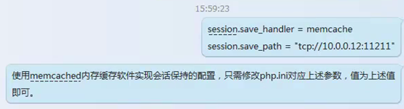

**通过IP访问基于域名的NGINX的虚拟主机的时候，默认会访问第一个虚拟主机**

